Documentation, Airport, Luggage and Medication

Passport:
Haitian authorities require that all Americans entering Haiti have a valid passport. You will not be allowed into Haiti without one. All travelers should bring a colored photocopy of their passport in the event that something should happen to your original.

Airport Protocol:
On the plane, you will be given 2 forms. You will be given a “green” card that you need to have when you depart Haiti. Do not lose this. Tuck it in your passport. Your Haiti address is: Route 1, Saintard, Arcahaie. Haiti. Your Haitian phone number is (509)4875-6819.

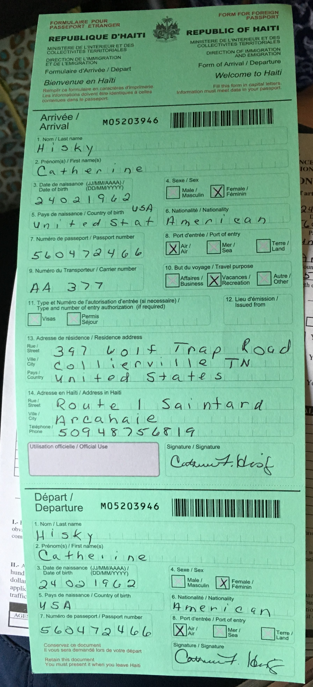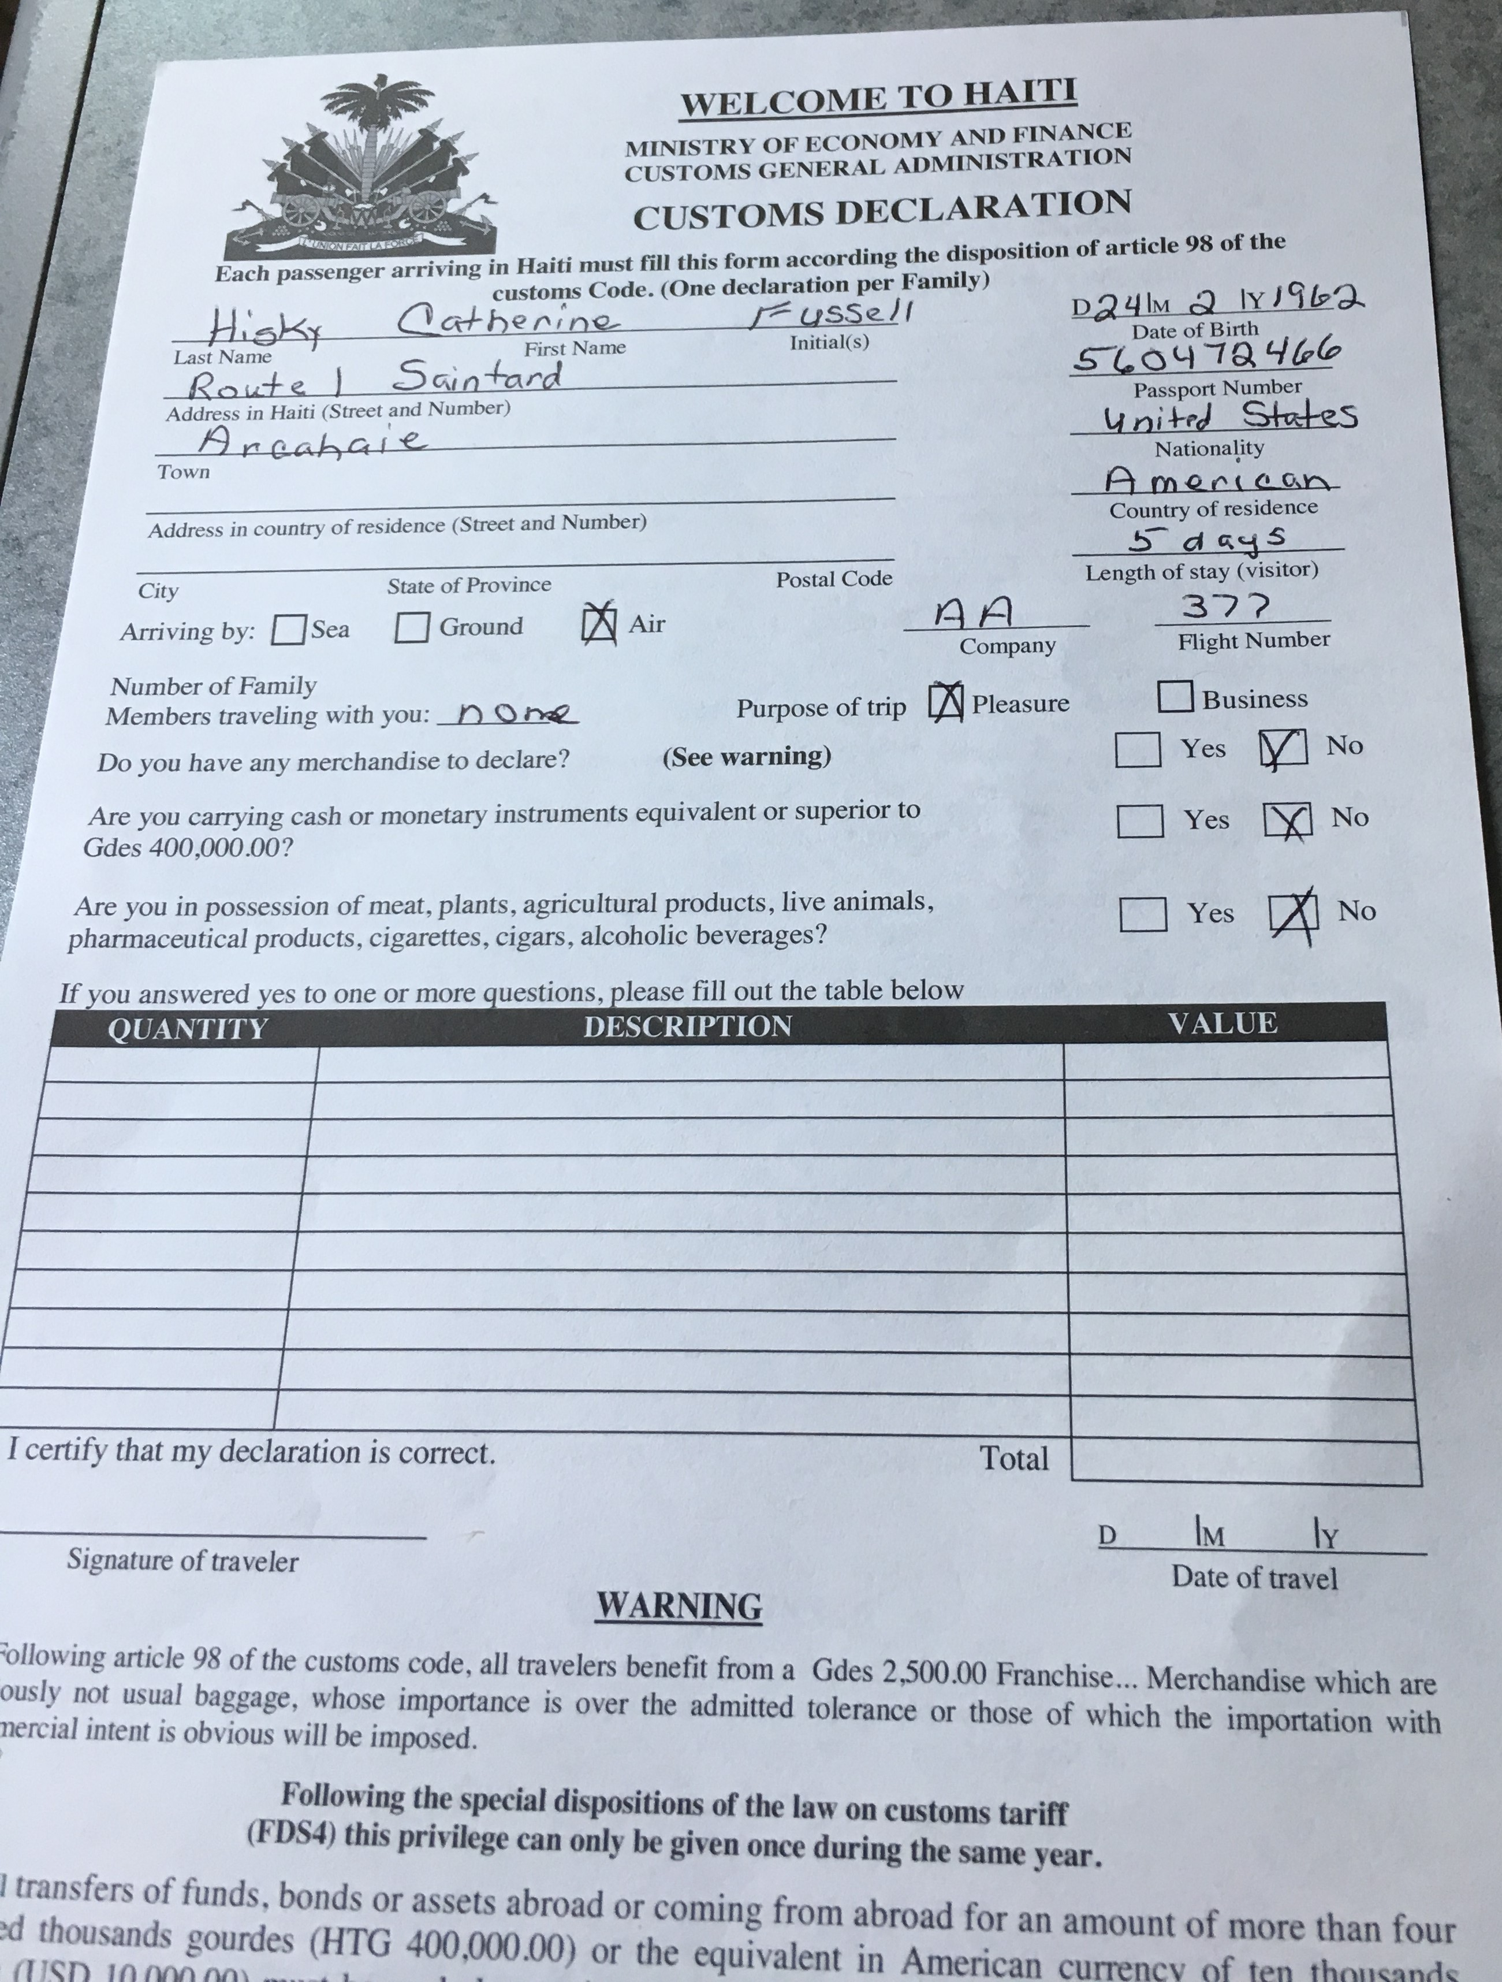 Once you arrive in Haiti, follow the rest of the crowd to immigration. Here you will pay a $10.00 “tourist fee” and get your passport stamped. They will not accept any money that is written on or torn.
They will take your green form and give you the tear off piece at the bottom. (Do not lose this green card.)
Once you walk downstairs, you can rent a luggage cart for $2.00 and head straight for the luggage carousel. Keep your eye out for your bags. Sometimes they are thrown in a corner of the room if the carousel is too crowded. When looking for your bags and again when exiting the airport say NO MESI to everyone who is trying to help carry bags. La Limye’ has hired specific people to help but you will not see them until you get to the lobby or outside. If you allow other people to help, it can create problems and cost you money.
You will then proceed to Customs and here they will check your baggage claim stickers and take your white form. If they ask what is in your bags, say “supplies for an orphanage.” If you say medicine, no need to mention your personal medicine, they will take you into another room and search your bags. There is only one exit door. La Limye’ worker will try to meet you inside, but sometimes they are not allow inside the airport, check outside for La Limye’ worker, they will be in a La Limye’ Shirt.
If for some reason, they get stuck in traffic and you cannot find them, return into the airport. DO NOT go into the parking lot.
When looking for your bags and again when exiting the airport say NO MESI to everyone who is trying to help carry bags. La Limye’ has hired specific people to help but you will not see them until you see La Limye workers outside. If you allow them to help, it can cause a riot and a lot of money.

Luggage:
Everyone is permitted 2 large piece of luggage weighing no more than 50 pounds and a carry on and a backpack we suggest that you use the carry on and backpack for your personal items so that you are able to use the checked bags for group items or supplies that the ministry needs. La Limye’ usually has supplies we need to transport into Haiti, and moving these as baggage is an efficient way to do this. We suggest using duffle bags; and we can provide these upon request. This allows the bags to be compacted for the trip home to minimize baggage fees. This will vary for each group.

Special Note, sharp objects such as nail files, clippers and knives will not be allowed in your carry on, as well as peanut butter. Please pack in your luggage.

Immunizations:
We recommend you seek professional advice from your doctor regarding immunizations for your trip to Haiti. Typical immunizations include tetanus and influenza, typhoid and hepatitis A and B vaccines, which provide long-term protection. You should also consult your doctor about anti-malaria medications. Make sure your shot records are up-to-date!

Medications:
Medical identification (tags, bracelet, card, etc.) must be carried by anyone with chronic illness such as diabetes or heart conditions. If you take prescription medications, bring enough to last the entire trip. We suggest that each person bring with them an anti-nausea/motion sickness drug like Phenergan and an anti-diarrheal medication like Imodium, sunscreen and bug spray containing Deet.
Returning to the State:
There is now an app called Mobil Passport that speeds up the process of getting thru customs. Its moves you to the front of the line. We recommend you download the app before leaving the country and set up your profile.

