Packing List

Remember the 3-1-1 rule:
3.4 ounce bottle or less (by volume)
1 quart-sized clear plastic zip-top bag
1 bag per passenger placed in the screening bin

In your Carry On (suggestions):
At least one change of clothes in case your suitcase gets lost.
• Medicine – any prescription meds you are taking, malaria meds, Band- Aids, first-aid ointment, diarrhea and motion sickness medication, cold tablets, ibuprofen, and Wet Ones
• Snack food for airport and daily travels
• Rain poncho (if arriving during rainy season)
• Sweat Rag/Bandana
• Camera (Optional)
• Passport-must be on your person!!
• Money – small bills
• Bible and journal
• Light sweatshirt/jacket for cold airplane and mild evenings in Haiti
• Things to do the plane (book, magazine, etc)
• Bottled Water PURCHASE AFTER GOING THROUGH SECURITY so you have safe drinking water while waiting for your bags when you arrive in Haiti.
• Refillable Water Bottle
• Toiletries – Toothpaste and toothbrush, shampoo, lotion, deodorant, hair brush, hand sanitizer, sunscreen, insect repellent
• Color photocopy of passport in checked luggage
• Gals – nice skirt/dress for church, no sleeveless shirts or flip-flops for church. Work clothes can be knee length skirts and shorts, tanks with 2” wide straps and t-shirts; – it will be hot and dirty on the road.
• Guys – nice shirt and pants for church, no sleeveless shirts or flip-flops for church. Work clothes can be shorts, light weight pants, t-shirts – it will be hot and dirty on the road.
• One pair of water shoes or sandals and one pair of comfortable walking shoes
• Hat for sun protection if desired
• One piece swim suit with gym shorts

A friendly travel tip:
If your airline wants you to check your carry-on, just refuse; unless it’s too large to fit the compartment, they can’t force you to check it. If you do check it, make sure there is nothing valuable inside. Be sure to take your medications, camera, phone and passport out. The Haitians who take the luggage off the place will go through it and things have been missing.

When traveling in a group, make your bags distinctive by placing a brightly colored ribbon or luggage tag on the handle. Take a picture of it before you check it with the airlines so that it can be easily identified in case it is “misplaced”. It’s strongly recommended that large teams have matching tags or tape.

***Jewelry***:
Leave it at home! We do not want to bring attention to ourselves with expensive jewelry or diamonds. This also reduces the possibility of theft or loss.

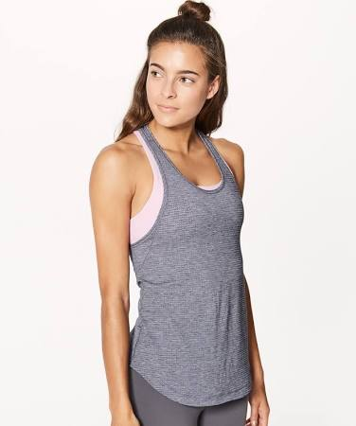
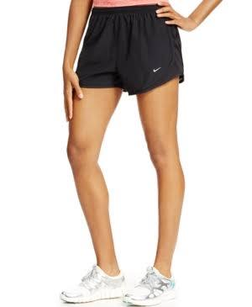Below is an example of what is NOT acceptable!

This is what IS acceptable!!
